National Historical Machinery Association Inc
ABN: 12 908 216 532 Incorporation No. A0020801V

President: Mr. Peter Garnham Secretary: Mr. Ken Bock Treasurer: Mr Daryl Whateley

All Correspondence to the Secretary: P O Box 304, STRATHDALE, VIC.
Phone: 03 5444 1113 Email: bock-1@bigpond.com

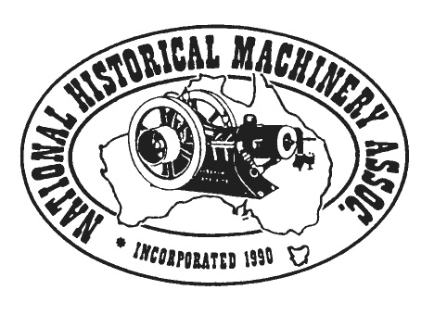

12 February 2021

To All NHMA Inc Member Clubs:

2021 NHMA Annual General Meeting

Due to the uncertainty surrounding State Border Closures,

the NHMA Committee of Management recently decided that it may not be possible to hold

a 'face to face' Annual General Meeting in 2021.

Your club is advised that the AGM will again take the form of a 'Postal Ballot' in 2021.

The NHMA Executive is endeavouring to 'post' relevant reports, advice of COM nominees,

the NHMA Ballot Paper & stamped, addressed return envelope, by late March -
more info via email later.

Your Club's patience and assistance with this matter is greatly appreciated!! It is hoped that the Association may move into more 'normal' times in 2022.

Meanwhile, if at all possible, keep contact with your members, hold small events that are within the boundaries of your State's COVID regulations. If all else fails, phone or email your members - they may appreciate a chat; just to keep in touch!!

Keep well & Kind Regards to all,

Ken F Bock
Secretary, NHMA Inc

